**Semester One Examination 2018**

**Question/Answer Booklet**

**APPLIED INFORMATION TECHNOLOGY UNIT 1**

Student Name: _____________________________________

Teacher’s Name: _____________________________________

**Time allowed for this paper**

Reading time before commencing work: ten minutes

Working time for paper: 2 1/2 hours

**Materials required/recommended for this paper**

***To be provided by the supervisor*** This Question/Answer Booklet Multiple Choice Answer Sheet

***To be provided by the candidate***

Standard items: pens (blue/black preferred), pencils (including coloured), sharpener,

correction fluid/tape, eraser, ruler, highlighters

Special items: nil

**Important note to candidates**

No other items may be taken into the examination room. It is **your** responsibility to ensure that you do not have any unauthorised notes or other items of a non-personal nature in the examination room. If you have any unauthorised material with you, hand it to the supervisor **before** reading any further.

***Structure of this paper***

|  |  |  |  |  |  |
| --- | --- | --- | --- | --- | --- |
| Section | Number of questions available | Number of questions to be answered | Suggested working time  (minutes) | Marks available | Percentage of total exam |
| Section One:  Multiple-choice | 15 | 15 | 15 | 15 | 15 |
| Section Two:  Short Answer | 7 | 7 | 40 | 77 | 25 |
| Section Three:  Extended Answer | 1 | 1 | 35 | 36 | 20 |
| Section Four:  Scenario | 1 | 1 | 60 | 45 | 40 |
|  |  |  | [Total marks] | | 100 |

***Instructions to candidates***

1. The rules for the conduct of School Curriculum and Standards Authority Council WACE examinations are detailed in the *Student Information* *Handbook*. Sitting this examination implies that you agree to abide by these rules.
2. Answer the questions according to the following instructions.

Section One: Answer **all** questions on the separate Multiple-choice Answer Sheet

provided. For each question shade the box to indicate your answer. Use only a blue or black pen to shade the boxes. If you make a mistake, place a cross through that square, do not erase or use correction fluid, and shade your new answer. Marks will not be deducted for incorrect answers. No marks will be given if more than one answer is completed for any question.

Sections Two, Three and Four: (Short, Extended and Scenario): Answer **all** questions. Write answers in this Question/Answer Booklet.

1. You must be careful to confine your responses to the specific questions asked and to follow any instructions that are specific to a particular question.
2. Spare pages are included at the end of this booklet. They can be used for planning your responses and/or as additional space if required to continue an answer.

* Planning: If you use the spare pages for planning, indicate this clearly at the top of the page.
* Continuing an answer: If you need to use the space to continue an answer, indicate in the original answer space where the answer is continued, i.e. give the page number. Fill in the number of the question(s) that you are continuing to answer at the top of the page.

**Section One: Multiple-choice 15% (15 Marks)**

This section has **fifteen (15)** questions. Answer **all** questions on the separate Multiple-choice Answer Sheet provided.

For each question shade the box to indicate your answer. Use only a blue or black pen to shade the boxes. If you make a mistake, place a cross through that square. Do not erase or use correction fluid. Shade your new answer.

Marks will not be deducted for incorrect answers.

No marks will be given if more than one answer is completed for any question.

Suggested working time: 15 minutes.

Which computer hardware component performs the following functions:

* Receives inputs
* Decodes and processes actions
* Delivers outputs
  1. The motherboard
  2. The CPU
  3. RAM
  4. USB ports.

Which type of operating system is best suited to providing the ability for multiple devices to connect to a single networked printer?

* 1. Desktop OS
  2. Mobile OS
  3. Tablet OS
  4. Server OS.

1. When using work created by another person, you have a legal obligation to treat their work with respect. By respecting the work created by others, you are acknowledging the other person’s:
   1. Privacy
   2. Ownership
   3. Moral rights
   4. Reputation.

The image to the right was constructed using tiny photos arranged in a grid pattern. This grid pattern creates the Twitter logo and background.

Using small shapes in this way is similar to which graphics file type?

* 1. .jpeg
  2. .svg
  3. .mpeg
  4. .mp3

When making a spreadsheet, which formula allows the user put a value in a cell on the basis of meeting a certain criteria.

* 1. SUM
  2. VLOOKUP
  3. AVERAGE
  4. IF

When reading about the use of colour in digital design, a student finds a reference to the term *monochromatic colours*. Which of the following statement best describes monochromatic colours?

* 1. Three or four successive colours on the colour wheel that can create a serene, harmonious feel
  2. When different shades of one colour are used on a web page or poster to create unity
  3. When opposite colours are used on a colour wheel to create contrast
  4. A range of cool colours are used to create a feeling on a website

Which of the following is not a Design Principle

* 1. Colour
  2. Balance
  3. Unity
  4. Dominance.

Which rule states that the points of interest on a visual composition are best displayed when the main subject is positioned by dividing the composition into three equal columns and rows and

* 1. To organise content into groups
  2. For the improvement of readability of text
  3. When a designer wants to create a visual impact
  4. To “de-clutter” a page.

Which of the following peripheral is an output device?

* 1. Multimedia Projector
  2. Keyboard
  3. CPU
  4. Bluetooth mouse.

When you download software to your computer that allows a trial for 30 days, you are using:

* 1. Open source software
  2. Freeware
  3. Closed source software
  4. Shareware.

Which of the following is **NOT** an example of **lossy graphic (compression)**?

* 1. JPG
  2. BMP
  3. GIF
  4. PNG

A new site has been created that allows users to upload and share images and videos. This could best be described as:

* 1. A media sharing site
  2. An educational network
  3. A social connection site
  4. A blogging site.

Which of the following listed file types was created by Microsoft® for use in producing audio files?

* 1. .mp3
  2. .wav
  3. .gif
  4. .wma

Which of the following describes a working file type

* 1. This is the final file type used after completing a task.
  2. A JPG is an example of this
  3. This file type needs to be consistent with being able to be used across multiple types of software.
  4. This file type allows for the use of layers in an image while working on it

When creating an online magazine article, an author places an image on the top right corner of a text based page. In terms of visual composition, the author has placed the image in the:

Image

**Title**

**Section One: Answer all questions on the separate Multiple-choice Answer Sheet**

**provided. For each question shade the box to indicate your answer. Use only a blue or black pen to shade the boxes. If you make a mistake, place a cross through that square, do not erase or use correction fluid, and shade your new answer. Marks will not be deducted for incorrect answers. No marks will be given if more than one answer is completed for any question.**

**Sections Two, Three and Four: (Short, Extended and Scenario): Answer all questions. Write answers in this Question/Answer Booklet.**

**3. You must be careful to confine your responses to the specific questions asked and to follow any instructions that are specific to a particular question.**

**4. Spare pages are included at the end of this booklet. They can be used for planning your responses and/or as additional space if required to continue an answer.**

Section One: Answer all questions on the separate Multiple-choice Answer Sheet

provided. For each question shade the box to indicate your answer. Use only a blue or black pen to shade the boxes. If you make a mistake, place a cross through that square, do not erase or use correction fluid, and shade your new answer. Marks will not be deducted for incorrect answers. No marks will be given if more than one answer is completed for any question.

Sections Two, Three and Four: (Short, Extended and Scenario): Answer all questions. Write answers in this Question/Answer Booklet.

3. You must be careful to confine your responses to the specific questions asked and to follow any instructions that are specific to a particular question.

4. Spare pages are included at the end of this booklet. They can be used for planning your responses and/or as additional space if required to continue an answer.

* 1. Primary optical area
  2. Fallow area
  3. Terminal area
  4. Dead zone.

End of Section One

**Section Two: Short Answer 25% (77 Marks)**

This section contains **seven (7)** questions. Answer **all** questions. Write your answers in the spaces provided.

Spare pages are included at the end of this booklet. They can be used for planning your responses and/or as additional space if required to continue an answer.

* Planning: if you use the spare pages for planning, indicate this clearly at the top of the page.
* Continuing an answer: if you need to use the space to continue an answer, indicate in the original answer space where the answer is continued, i.e. give the page number. Fill in the number of the question that you are continuing to answer at the top of the page.

Suggested working time: 40 minutes.

**Question 16**

Define the following terms and give an example of each:

1. Hardware

(3 marks)

Definition:

Example:

1. Operating System

(3 marks)

Definition:

Example:

1. Applications

(3 marks)

Definition:

Example Two:

**Question 17**

The Copyright Act 1968 (Australia) offers protection to creators of works in Australia.

1. Define what the Copyright Act 1968 does and give four examples of forms of content it covers.

(6 marks)

Definition:

Examples:

1.

2.

3.

4.

1. The Act allows for some exemptions from Copyright Law under the area of *fair dealing.* List **two (2)** examples wherea fair dealingexemption would be granted.

(2 marks)

Example One:

Example Two:

1. One way students can acknowledge the work of others is by providing references at the conclusion of an assignment. List **four (4)** important parts of a reference that is citing the use of a webpage.

(4 marks)

Part One:

Part Two:

Part Three:

Part Four:

**Question 18**

You are the team leader working on a multimedia project and your colleagues have collected many digital resources of varying types. You are tasked with organising this data into appropriate folders.

(4 marks)

1. The image to the right shows how the files have been   
     
   collected and placed in a folder named “Resources”.



Resources

Background.mp3

Sky.png

Poster.svg

Birds.wav

Tree.bmp

Flight.gif

Look at each file type and in the space below organise the data into a folder structure that best represents the different types of media files shown. Include the files in your new file structure.



Resources

1. For the files you have organised on the previous page, choose the correct file to match the descriptions below:

(3 marks)

Description One: This file does not pixelate when resized.

File: ____________________________________________________________

Description Two: This file can be displayed with a transparent background.

File: ____________________________________________________________

Description Three: This file is useful for sharp edged logos that do not have too many colours.

File: ____________________________________________________________

1. Distinguish between the terms *Vector* and *Raster* when applied to graphics files.

(2 marks)

**Question 19**

It can be said that the development of software never stops. Even after it has been released for public use, software is constantly being updated by software vendors.

1. Give **two (2)** items that a software update may include that will improve the software.

(2 marks)

One:

Two:

When purchasing a computer, **explain** three considerations that a manager would need to make before making the purchase

(3 marks)

One

Two

Three

1. In some cases, members of the public can access and modify the software code for a particular application or operating system and create their own updates. These updates can then be made available for use by the public. For most software, however, the developer creates and distributes the updates.

Using your knowledge of the types of software licensing, explain how the code for some software can be accessed whereas, in most cases, the code is unable to be edited by the public.

(2 marks)

1. For your answer to part (c) above, give an example of an operating system that matches the two update methods described.

(2 marks)

Public creates updates: _____________________________________________

Developer creates updates: _____________________________________________

**Question 20**

Cyber bullying is often in the media and has become one of the greatest concerns of parents, teachers and support staff in schools.

1. Describe **three (3)** actions you can take to be considered a responsible user of Social Networking.

(6 marks)

One:

Two:

Three:

1. Cyber bullying can take many forms. Explain **four (4)** forms of cyber bullying?

(8 marks)

One:

Two:

Three:

Four:

1. You have been asked to give advice to young students regarding strategies they could use to manage or limit the cases of cyber bullying they may encounter. Describe **two (2)** strategies you would include in your advice.

(4 marks)

One:

Two:

**Question 21**

When designing digital solutions and products, design elements and principles are at the forefront during the design process.

1. In **three (3)** or **four (4)** sentences, explain the relationship between elements of design and principles of design. In your definition give an example

(3 marks)

1. Typography is also a significant part of the design process. Explain what is meant by the term Typography.

(2 marks)

1. Explain the difference between San Serif and Serif font

(2 marks)

1. Explain two characteristics of **font** and explain why it is significant in webpage design

(4 marks)

Characteristic 1

Reason

Characteristic 2

Reason

**Question 22**

The screenbelow shows an excel spreadsheet showing student results.

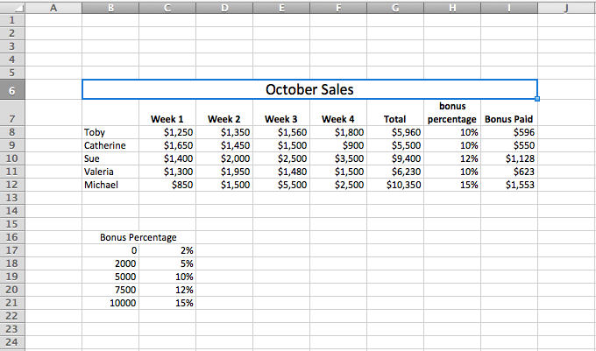

* 1. In the cell reference G8, there is a total for Toby’s sales. Write the formula that would appear in G8 to calculate this.

(2 marks)

* 1. In cell reference H11, it shows how much bonus percentage Valeria is paid. Write the formula which would calculate the percentage she should receive.

(5 marks)

* 1. In cell reference I10, the cell reference refers the amount of bonus Sue should be paid. Write the formula to calculate this

(2 mark)

**Section Three: Extended Answer 20% (36 Marks)**

This section contains **one (1)** question. Write your answers in the spaces provided and number your answers clearly.

Spare pages are included at the end of this booklet. They can be used for planning your responses and/or as additional space if required to continue an answer.

* Planning: If you use the spare pages for planning, indicate this clearly at the top of the page.
* Continuing an answer: If you need to use the space to continue an answer, indicate in the original answer space where the answer is continued, i.e. give the page number. Fill in the number of the question that you are continuing to answer at the top of the page.

Suggested working time: 35 minutes.

**Question 23**

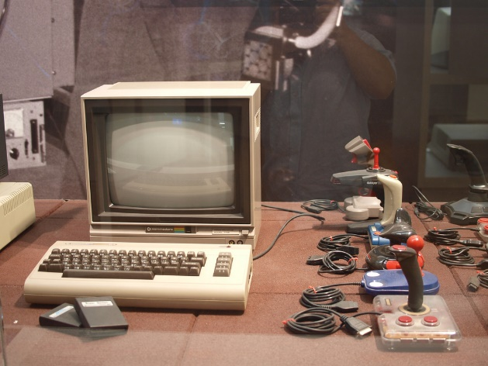In 1982, a new computer, the Commodore 64 was launched. It went on to become one of the most popular personal computers of the time, amassing sales well in excess of 15 million over a 12 year period.

It was particularly popular with gaming enthusiasts and those learning to code. The image to the right shows the keyboard and monitor (NB: there is no mouse). There are also gaming joysticks that plugged into serial ports.

The “64” part of the Commodore’s name came from the amount of RAM installed – 64kb! The device also had a single core, 1.02MHz CPU. There was no hard disk and all programs ran on a “Floppy Disk” – pictured below.

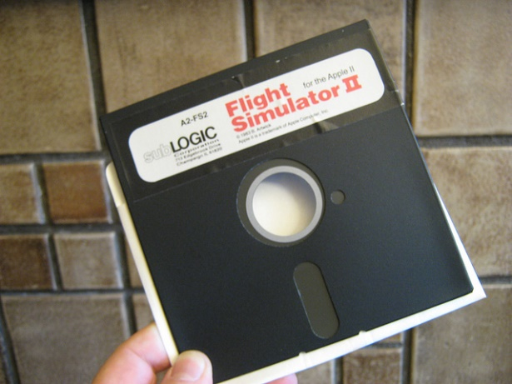This disk had a capacity of 80Mb which was later improved to a 1.44Mb version in the mid-1980s.

Games and other programs ran off this disk which was inserted into a separate drive that was also connected via serial ports.

These computers are still available today online as collector items and have a strong “retro” trend following across the globe.

Answer the questions that follow relating where possible to the Commodore 64 and your understanding of modern trends in hardware and software.

1. Most devices currently have 4-8Gb of RAM and up to a 1.0Tb of disk. Using this information as an example, explain the function of *Primary* and *Secondary* storage in a computer system.

(4 marks)

Primary Storage:___________________________________________________________________________________

Secondary Storage:_______________________________________________________________________________

1. From the article, list **three (3)** peripheral devices that were common to the Commodore 64 computer?

(3 marks)

One:

Two:

Three:

1. The operating system on a Commodore 64 was stored in Read Only Memory (ROM) on the motherboard. Where is the modern day operating system installed on mobile devices and laptops?

(1 mark)

1. List **four (4)** functions of an operating system

(4 marks)

Function One:______________________________________________________________________________________

Function Two:______________________________________________________________________________________

Function Three:____________________________________________________________________________________

Function Four:______________________________________________________________________________________

1. List four examples of Operating Systems commonly used today and the device you would find them on.

(4 marks)

1

2

3

4

1. The Commodore 64 ran 8-bit software which cannot execute on modern 64-bit operating systems. Give **two (2)** possible ways enthusiasts can still enjoy playing those retro games?

(2 marks)

One:

Two:

1. What is meant by the phrase **work-life balance**? Explain the effect technology is having on work-life balance and in your explanation make reference to two technologies that have contributed to this. (4 marks)

For the following question refer to the table below

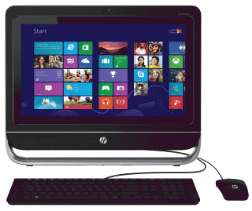

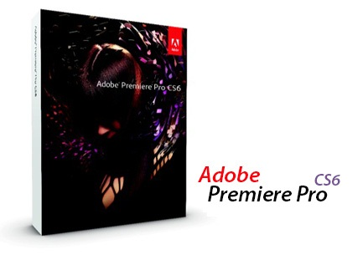

|  |  |
| --- | --- |
| **Specifications for Adobe Premiere CS6** | **Desktop Computer** |
| Intel® Core™2 Duo or AMD Phenom® II processor; 64-bit support required  Microsoft® Windows® 7 with Service Pack 1 minimum  4 GB of RAM (8 GB recommended)  4 GB of available hard-disk space for installation;  Additional disk space required for preview files and other working files (10 GB recommended)  1280x900 display  Graphics card (recommended) | Windows 8 DVD +/- & CD Recorder 6 USB Ports On board graphics card 500 GB HDD 4 GB RAM 1600 x 900 Screen Resolution |

1. Based on the information above, would you recommend Adobe Premiere be loaded onto this computer

(5 marks)

Recommendation: _______________________________________

Reason 1:

Reason 2:

1. What does a Graphics Card do and how does it help the CPU?

(3 marks)

1. If you are a high school student, what are the advantages of purchasing a laptop over a desktop computer

(3 marks)

1.

2.

3.

1. If you are a student, what are the disadvantages of purchasing a laptop over a desktop computer

(3 marks)

1.

2.

3.

**End of Section Three**

**Section Four: Scenario 40% (Marks)**

There is **one (1)** question in this section. You must answer **all** parts of the question.

Spare pages are included at the end of this booklet. They can be used for planning your responses and/or as additional space if required to continue an answer.

* Planning: If you use the spare pages for planning, indicate this clearly at the top of the page.
* Continuing an answer: If you need to use the space to continue an answer, indicate in the original answer space where the answer is continued, i.e. give the page number. Fill in the number of the part of the question that you are continuing to answer at the top of the page.

Suggested working time: 60 minutes.

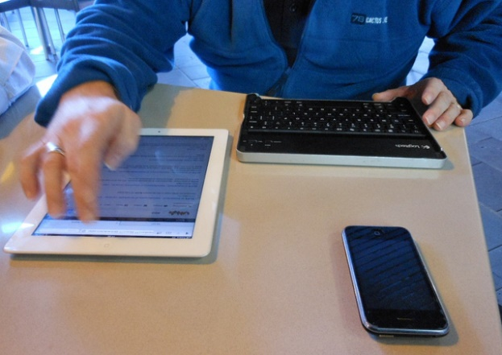A developer has offered you a contract to work with a project team on the development of a fitness App that will work across multiple platforms.

There is a trend with developers to create Apps that will work across multiple platforms as users are now demanding that they get the same user experience across many devices they now own – laptop, tablet and mobile phone.

Adding to this trend is the increase in the use of wearable devices such as smart watches and fitness trackers. These require better integration with mobile devices, providing more challenges for developers.

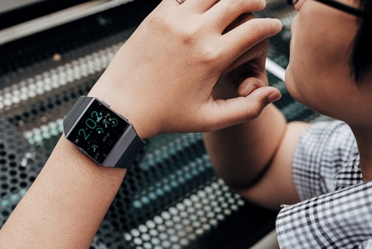The team you will work with have been asked to build a cross-platform App with compatability for fitness trackers. The user will add the make and model of their tracker and the App will have pre-installed code that will allow for the integration of the wearable device.

The App will have the following;

1. Pedometer Recording of steps
2. GPS map of running
3. sample exercise programs
4. daily goal setting
5. meal planning
6. links to Social Media

Also, there will be links to dietary resources, meal planners and kilojoule counters.

As your skills lie in the area of User Interface Design, you will be tasked with the design of the logo and home screen for the App. The programmers will be responsible for the cross-platform and wearable support and the Marketing Team will supply the necessary corporate information.

The App will be called “SpeedFit”.

**Question 24**

1. The Marketing Team have supplied you with a Style Guide that you must follow in the design of the home screen. Describe **four (4)** essential components for a style guide that would be applicable for this screen.

(8 marks)

Component One:__________________________________________________________________________________

Component Two:__________________________________________________________________________________

Component Three:_________________________________________________________________________________

Component Four:__________________________________________________________________________________

1. Describe the Target Audience of this proposed App, for each characteristic describe how it will affect your App design.

(6 marks)

Characteristic

Effect on Design

Characteristic

Effect on Design

Characteristic

Effect on Design

1. Describe the purpose of this App

(2 marks)

* + 1. List **three (3)** operating systems that may have to cater for in your development of this mobile App.

(3 marks)

One:___________________________________________________________

Two:___________________________________________________________

Three:______________________________________

1. Design a logo for the new SpeedFit app

Explain the meaning of each, in your annotations;

1. Design principles and elements you used (4 marks)
2. Typography (2 marks)
3. Colour (2 marks)
4. Image (2 marks)
5. Explain the Rule of Thirds in regards to the placement of content on your App page. Use the small rectangle below to help explain (4 marks)

1. You are now required to produce a hand drawn sketch that will show the general layout of the home screen of your App. You do not need fine details like actual text or graphics, but rather their positioning on the screen.

For the sketch, you need to include the following:

* + 1. The location of a company Logo (you don’t need to draw in detail). You need to justify why you placed it in a particular position.

(2 marks)

* + 1. **Two (2)** elements of design you have considered and the principles of design to which they relate.

(4 marks)

* + 1. An explanation of how you will incorporate **two (2)** target audience characteristics into your layout.

(4 marks)

* + 1. Indicate the role that Typography will play in the design of the home screen.

(2 marks)

**Draw your sketch here with annotations**

END OF EXAM

Question Number:

Question Number:

Spare space for sketches

Question Number:

**END OF EXAMINATION**

**ACKNOWLEDGEMENTS**

**Section 1 - Multiple Choice**

Question 4

Image by Marco Verch under the license of   
<https://creativecommons.org/licenses/by/2.0/>

Question 7

Image by <https://pixabay.com/en/shapes-obejcts-cylinder-cones-35091/>

under the license of

<https://pixabay.com/en/service/terms/#usage>

**Section 3 - Three Extended Answer**

Question 23

Old Gaming Computer image by [Tomislav Medak](https://www.flickr.com/photos/tomislavmedak/) under license of

<https://creativecommons.org/licenses/by/2.0/>

Old Floppy Disk by Glenn Fleishman under license of

<https://creativecommons.org/licenses/by/2.0/>

**Section 4 – Scenario**

Question 24

Smartwatch image by Tinh tế Photo under license of

<https://creativecommons.org/publicdomain/zero/1.0/>

Various mobile devices image by Michael Coghlan under license of

<https://creativecommons.org/licenses/by-sa/2.0/>